CAREER CELL UNDERGRADUATE ACADEMIC COUNCIL
Jñānaṃ̣ Paramam Śaktihī
INFORMED STUDENTS Creating awareness
about the various career opportunities
WISE
CHOICES
Perspectives and experiences from each domain required to make an informed decision
BRIGHT
CAREERS
Preparing studentsfor internships, placements, exams, university
applications and other opportunities
Things already covered:
ProcessGuidelines: Doubts!
Initiative planning and logistics, key aspects after ideation: Domain alignment and impact (demand analysis) Stakeholders and timeline
Publicity
D-Day planning
Duties of an academic coordinator
Learners' Space MANY INTERESTS | ONE SCHOOL
An online learning platform available during summer break
Includes a variety of courses under 6 schools: 1. CS & DS Summer School
2. Sustainability Summer School
3. Sports & Skills Summer School
4. Engineering Summer School
5. Sciences Summer School
6. Management Summer School
It is a collaboration with multiple clubs of the institute
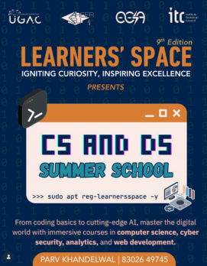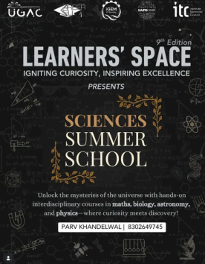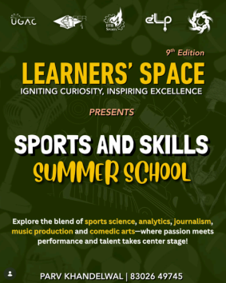
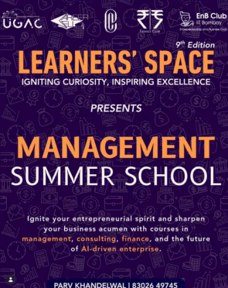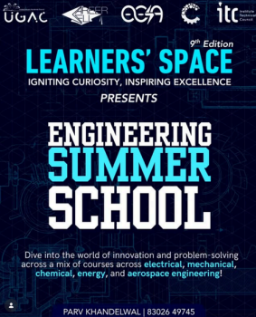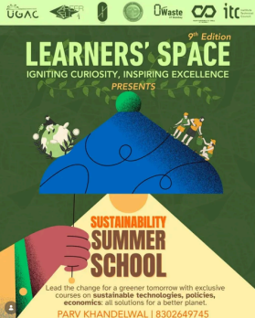
Learners' Space
MANY INTERESTS, ONE SCHOOL COORDINATORS’ WORK:
Initialization
Collaborations with Clubs
Website
In-process logistics and publicity Closure
Ponder on:
How to make it more enriching for the audience?
Fundae Talks!
Informal sessions by seniors from various backgrounds who share their institute experiences, giving TIPS and FUNDAES!
FUNDAE TALKS 1.0 FUNDAE TALKS2.0
1s and 0s of insti life
All about PORs and how to manage them with other activities?
Initiatives coming up in Summer
Think about what other topics can be covered under Fundae Talks that are not covered yet and hold significance to freshers
Booklets
We at Career Cell have a bunch of booklets to aid students throughout their career building in college. Some of them are mentioned in the slides ahead.
Please note that the booklets are accessible only through your LDAP-enabled G-suite account
Coordinator Work for Booklets
Pursuing Responses:
a. Personally messaging, following up
b. Taking interviews if required
c. Forging Connections with machau seniors!
Collating Responses:
a. Designing the resource keeping it easy for the user to navigate b. Transforming the responses collected into crisp, comprehensible information
Internship Guide 101
How can we improve user
experience?
Univ Internship Booklet
What are some scopes
for further
improvement?

Placement Bluebook
Is any information
missing that should be
added?
GRAD Booklet
Scrutinize the content,
does everything we
provide add value?
MBA Booklet
Whatare some other fields
for which such a booklet is
required?
UPSC Booklet
Is there a revamp
required?
Internship Preparation Program
Profile-Based
Preparation
Sessions
Sessions aimed to aid the understanding and bring more clarity about the profiles offered and the preparation. Collabs!
Internship Guide 101
A guide for domain-wise internship information and preparation material
Now released on ReaCH
Internship
Resume
Repository
Compiling resumes of seniors across multiple domains and companies
Now released on ReaCH
Univ Intern Booklet
A collab with EnPoWER.The booklet covers details about the application procedure, eligibility criteria, and scholarships for 100+ university intern programs.
Internship Pre Preparation Session
Women Internship Guidance Program
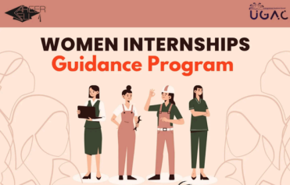
Getting Mentors AND Mentees Onboard
Finding, Collating and Sharing Women Specific
Internship Opportunities
Mapping Mentors and Mentees
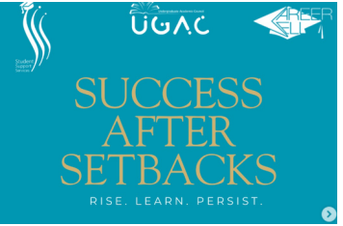
Success After Setbacks
Contacting Seniors and getting them
to share their stories
Making the Posts and Blogs
Placement Preparation Program!
_{Placement Bluebook}Profile-Based Preparation Sessions
Resume Repository
The Bluebook is a booklet comprising company-wise selection procedures and resources.
Sessions aimed to aid the understanding and bring more clarity about the profiles offered and the preparation.
Compiling resumes of seniors across multiple domains and comapnies.
GRAD Mentorship Program
In collaboration with EnPoWER
Consisted of the GRAD 101 Session, the mentorship program and the GRAD Booklet
Aimed to aid students who want to pursue further studies in STEM in universities abroad and in India
Deferred MBA at Harvard and M7 B School Session
Higher Studies! MBA Booklet
GRAD
Mentorship Program
In Conversation with NTU | GRE & TOEFL | University Fair What more can we cover?
Apping Session
Others
Collaboration with EnPoWER. Guidance session by seniors for apping in core and non-core domains.
Resume Making Session
Often conducted multiple times a year, catering to all the batches and to all their needs: Sophomores, Intern Season(thirdies), Placement Season(final-year students).
Certification Programs
Personal Effectiveness and Leadership Workshop (in collaboration with SSS
Common UGAC Events!
Academic Coordiator Duties
Handle the queries of all the students that may come up during registrations or otherwise by being their PoC.
Convocation/ Commencement/ Orientations Help organise all the institute-level events such as Freshie Orientation, Convocation/ Commencement etc.
Other Events
Help in the conduction of events such as Enthuse, ResCon, and Technical orientation.
Lukkha Nights!
Fun!
^{Senti} Photo Session
Hangouts! Birthdays!
Pizza Party post your Resume Making!
RuCCsat!
FAMILY!
Friends! Treats!
Follow! Instagram Page:
Contact us !
Parv Khandelwal
Institute Secretary Academic Affairs (UG) & Head, Career Cell 2025-26 8302649745
Preisha Desai
Institute Secretary Academic Affairs (UG) & Head, Career Cell 2026-27 9769623937
(Ignore the Earlier Number here)
Academic Coordinators, Career Cell 2025-26
Mridhula Vishwanath 9108224749
Saksham Agrawal
7857070220
Syed
Ali
6394872284
Tanish
Kharbanda 7385538716
Student queries and grievances redressal
Work of an ISAA
Assisting the
GSAA (UG)
Academic Policies
Proactively
looking for new opportunities in the Institute
Student
Representation
Representation in DACs
Assisting student representatives across academic units

